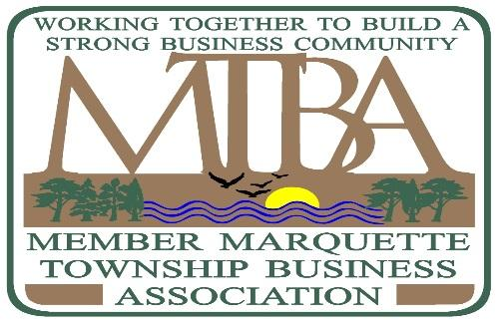
2463 US Hwy 41 W, Marquette MI 49855
(906) 228-0028 ● FAX (906) 226-2013

mtbatownshipbusiness@yahoo.com www.marquettetownship.biz
BOARD MEETING MINUTES
Tuesday, November 20th, 2018 – 11:30 am – Marquette Township Hall
1). Roll Call/ Round Robin- 11:38AM (DID NOT HAVE QUORUM)
- Roll Call

  - PRESENT:
- Frank Stabile, Chairman (Superior Oasis)
- Jenn Wallner, Treasurer (GMWWP, CPAs, P.C.)
- Alex Baysore (Representative for Todd Noordyk, Co-Chairman) (Great Lakes Radio, Inc.)
- Jessica Anders, Executive Secretary (Carpet Specialists)
- Adele Jacobson (Honor Credit Union)
  - ABSENT:
    - Peggy Loy (Century 21)
    - Tina Henson (Tru North Federal Credit Union)
    - Michael Morgan (First National Trust & Wealth Management)
    - Dr. Cynthia Wiggins (Alpha Omega Dental Center)
    - Scott Patrick (Carpet Specialists)
    - Jason McCarthy (Marquette Township)
    - Todd Noordyk, Chairman (Great Lakes Radio)

- Consent Agenda
  - Approval of September 18th, 2018 minutes
  - Treasurer’s Report- Executive Board approved payment of the below bills due to no quorum
    - Bank Statement Balances
      - Checking: $144.72
      - Savings: $ 7571.90
    - Budget Report:
    - Invoices to be Paid

      - Great Lakes Radio: $100
      - Jessica Anders for secretarial services: $131
      - GMWWP $72.85 (Postage for Membership drive)
      - Hudson’s Classic Grille: $247.76 (Lunch for Joint Meeting)

  - Correspondence –

- Regular Agenda –
  - Membership-

    - Membership Drive-
1). Jessica will send out E-mail week of December 20th reminding current members that membership dues are due by end of December for 2019.
2.) Jenn will send out invoices for current members.

    - 3 New and 17 total: As of 11-20-2018

    - Potential New Business List for 2018:
      - Meijer Store and C-Store (Meijer Gas Station), Subaru Car Dealership, Beam and Barrel, Gander Outdoors, New Lash Parlor in old Curran Coffee Shop, Superior Chaga, Sayklly’s, North Iron Church
      - Michael Morgan will speak with Fraco Concrete Products
      - Cynthia Wiggins will contact Remax and will get the other Dentists as well
      - Subaru and Riverside are set to be open by the end of 2019

  - New Business
    - Adele will talk to John again about the Cenex post office box since Cenex is now out of business.

  - Unfinished Business
    - Catch the Visions (Todd Noordyk) – Tree Lighting was November 27th. There were Facebook posts and websites posts regarding the event.
    - Beautification of the Corridor-
    - Joint Meeting with Township Board-
- Reports
  - Marquette Township Business Association Facebook Page – Member should let the board know about events going on with their businesses so that there can be posts on Facebook and on the website. The purpose of the MTBA website is promotions, news with businesses, and letting people know about major events, zoning news, etc.
  - Website (Alex Baysore) –Alex gave a report showing how many website posts, visits, and page views. There were questions if the board will take the reins of posting on the website or if Lauren, Todd, or Alex will be posting. The board should have control over the content. We must be consistent with posting on the website. We would like to post about activities and news going on with businesses, so we can help promote members. All website posts should be approved by the board before posting. There was an issue of too many pictures being posted with an article.
  - DDA Update (Todd Noordyk) –

  - Marquette Township Board Treasurer (Ernie Johnson)

  - Marquette Township Planning & Zoning Administrator (Jason McCarthy)

Meeting ended at 12:00 pm

NEXT MEETING: Tuesday, December 18th, 2018 at 12:00 PM at Hudson’s Classic Grill

